**IMPLEMENTATION IN PYTHON**

**FORWARD PROPAGATION IN SINGLE LAYER**

**Understanding Forward Propagation**

* **Forward propagation involves calculating the output of a neural network layer by applying weights and biases to input data, followed by an activation function.**
* **The example uses a coffee roasting model to illustrate how to compute activation values for neurons in a single layer.**

**Implementation Steps**

* **Each activation value is computed using a dot product of weights and inputs, adding a bias, and applying the sigmoid activation function.**
* **The results from the first layer are grouped into an array, which is then used to compute the output of the second layer in a similar manner.**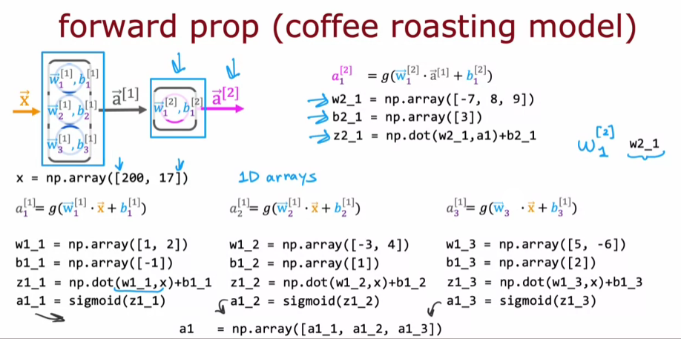

**Next Steps in Learning**

* **The content encourages learners to simplify the implementation for more complex neural networks rather than hard-coding for each neuron.**
* **Engaging with the provided code in the lab will reinforce understanding and prepare learners for more advanced concepts in neural network design.**

**GENERAL IMPLEMENTATION OF FORWARD PROPAGATION**

**Understanding the Dense Layer**

* **The dense function takes the activation from the previous layer and the parameters (weights and biases) for the current layer to compute the activations for the next layer.**
* **It involves stacking weight parameters into a matrix and bias parameters into a 1D array, which are then used in calculations.**

**Implementation Steps**

* **The number of units in the layer is determined by the shape of the weight matrix.**
* **A loop iterates through each unit to compute the activation values using the dot product of weights and activations, followed by applying the sigmoid function.**

**Connecting Layers in Forward Propagation**

* **The activations from one layer are used as inputs for the next layer, allowing for the sequential computation of activations through multiple dense layers.**
* **The final output of the neural network is derived from the last layer's activations.**

